#
# Here is a follow file.
# 20181130 SD#1357396 Create two new Dell servers m1-afs-prod2, ds-afs-prod2
# In this installation I’ve used configured during installation simple network interface in network 10.218.15.0/24.
# This network is used for Cobbler software. I’ve asked net-admins to configure ports of switch to be able to use the VLAN 1815.
#
................................................................................

From: Golovin Andrej Olegovich
Sent: Wednesday, November 28, 2018 12:51 PM
To: Belogrud Sergey Vladimirovich <s.belogrud@tinkoff.ru>
Subject: RE: Уточнение по SD#1357396

Требований к версии RHEL нет.

На ней должны работать tomcat 7.x, 8.x

Андрей Головин
Старший специалист
Тел.: +7 495 648-10-00, доб. 2228

From: Belogrud Sergey Vladimirovich
Sent: Wednesday, November 28, 2018 11:22 AM
To: Golovin Andrej Olegovich <a.golovin@tinkoff.ru>
Subject: RE: Уточнение по SD#1357396

А верисия rhel какая?
Например, 7.x или чётко такая и такая.

Сергей Белогруд
Старший системный администратор
Тел.: +7 495 648-10-00, доб. 2173

From: Golovin Andrej Olegovich
Sent: Wednesday, November 28, 2018 11:15 AM
To: Belogrud Sergey Vladimirovich <s.belogrud@tinkoff.ru>
Subject: RE: Уточнение по SD#1357396

Сергей, привет!

1. Наименование серверов.
m1-afs-prod02
ds-afs-prod02
2. Какую ОС устанавливать.
RHEL
3. Конфигурация raid масса.
По аналогии с m1-afs-prod, или можем обсудить твои варианты.
4. Какие разделы дисковые создавать, куда смонтировать.
По аналогии с m1-afs-prod
5. Прочее, что имеет важность.
Нужно создать пользователей с такими же UID что и на старых серверах, т.к. это завязано на доступ приложения к файлам в сетевой папке /mnt/AFS_prod/

Андрей Головин
Старший специалист
Тел.: +7 495 648-10-00, доб. 2228

From: Belogrud Sergey Vladimirovich
Sent: Tuesday, November 27, 2018 12:39 PM
To: Golovin Andrej Olegovich <a.golovin@tinkoff.ru>
Subject: Уточнение по SD#1357396

Добрый день.

Требуется уточнение по SD#1357396.

Нужны детали по подготовке двух серверов к использованию.
1. Наименование серверов.
2. Какую ОС устанавливать.
3. Конфигурация raid масса.
4. Какие разделы дисковые создавать, куда смонтировать.
5. Прочее, что имеет важность.

В netbox ссылка на два сервера: https://netbox.tcsbank.ru/dcim/devices/?tag=purchase_oct2018_type06_app_afs

................................................................................

#
# Here is a information about similar old server.
#

[root@m1-afs-prod ~]# dmidecode -t system
# dmidecode 2.11
SMBIOS 2.8 present.
# SMBIOS implementations newer than version 2.7 are not
# fully supported by this version of dmidecode.

Handle 0x0100, DMI type 1, 27 bytes
System Information
Manufacturer: HP
Product Name: ProLiant DL380p Gen8
Version: Not Specified
Serial Number: CZ22500MJQ
UUID: 31323436-3630-5A43-3232-3530304D4A51
Wake-up Type: Power Switch
SKU Number: 642106-421
Family: ProLiant

Handle 0x2000, DMI type 32, 11 bytes
System Boot Information
Status: No errors detected

[root@m1-afs-prod ~]#

[root@m1-afs-prod ~]# cat /etc/redhat-release
Red Hat Enterprise Linux Server release 6.2 (Santiago)
[root@m1-afs-prod ~]#

[root@m1-afs-prod ~]# hpssacli controller all show config

Smart Array P420i in Slot 0 (Embedded) (sn: 0014380241418B0)

Port Name: 1I

Port Name: 2I

Internal Drive Cage at Port 1I, Box 2, OK

Internal Drive Cage at Port 2I, Box 2, OK
array A (SAS, Unused Space: 0 MB)

logicaldrive 1 (136.7 GB, RAID 1, OK)

physicaldrive 1I:2:1 (port 1I:box 2:bay 1, SAS, 146 GB, OK)
physicaldrive 1I:2:2 (port 1I:box 2:bay 2, SAS, 146 GB, OK)

array B (Solid State SAS, Unused Space: 0 MB)

logicaldrive 2 (372.6 GB, RAID 1+0, OK)

physicaldrive 1I:2:3 (port 1I:box 2:bay 3, Solid State SAS, 200 GB, OK)
physicaldrive 1I:2:4 (port 1I:box 2:bay 4, Solid State SAS, 200 GB, OK)
physicaldrive 2I:2:5 (port 2I:box 2:bay 5, Solid State SAS, 200 GB, OK)
physicaldrive 2I:2:6 (port 2I:box 2:bay 6, Solid State SAS, 200 GB, OK)

SEP (Vendor ID PMCSIERA, Model SRCv8x6G) 380 (WWID: 50014380241418BF)

[root@m1-afs-prod ~]#

[root@m1-afs-prod ~]# uname -a
Linux m1-afs-prod 2.6.32-220.el6.x86_64 #1 SMP Wed Nov 9 08:03:13 EST 2011 x86_64 x86_64 x86_64 GNU/Linux
[root@m1-afs-prod ~]#

[root@m1-afs-prod ~]# lsblk -o NAME,MOUNTPOINT,FSTYPE,SIZE
NAME MOUNTPOINT FSTYPE SIZE
sr0 1024M
sdb LVM2_member 372.6G
└─vg_data-lvol0 (dm-1) /mnt/afs ext4 372.6G
sda 136.7G
├─sda1 /boot ext4 256M
├─sda2 [SWAP] swap 16G
├─sda3 LVM2_member 19.5G
│ ├─vg-LogVol00 (dm-0) / ext4 8G
│ └─vg-LogVol01 (dm-3) /var ext4 11.5G
├─sda4 1K
└─sda5 LVM2_member 100.9G
└─vg_opt-LogVol00 (dm-2) /opt ext4 100.9G
[root@m1-afs-prod ~]#

[root@m1-afs-prod ~]# findmnt
TARGET SOURCE FSTYPE OPTIONS
/ /dev/mapper/vg-LogVol00 ext4 rw,relatime,barrier=1,stripe=64,data=ordered
├─/proc /proc proc rw,relatime
│ ├─/proc/bus/usb /proc/bus/usb usbfs rw,relatime
│ └─/proc/sys/fs/binfmt_misc binfmt_misc rw,relatime
├─/sys /sys sysfs rw,relatime
├─/dev udev devtmpfs rw,relatime,size=264608644k,nr_inodes=66152161,mode=755
│ ├─/dev/pts devpts devpts rw,relatime,gid=5,mode=620,ptmxmode=000
│ └─/dev/shm tmpfs tmpfs rw,relatime
├─/boot /dev/sda1 ext4 rw,relatime,barrier=1,stripe=256,data=ordered
├─/mnt/afs /dev/mapper/vg_data-lvol0 ext4 rw,relatime,barrier=1,stripe=128,data=ordered
├─/opt /dev/mapper/vg_opt-LogVol00 ext4 rw,relatime,barrier=1,stripe=64,data=ordered
├─/var /dev/mapper/vg-LogVol01 ext4 rw,relatime,barrier=1,stripe=64,data=ordered
│ └─/var/lib/nfs/rpc_pipefs sunrpc rpc_pipefs rw,relatime
├─/mnt/AFS_prod v6250-m1:/vol/integration_fs/integration3/AFS_prod nfs rw,relatime,vers=3,rsize=32768,wsize=32768,namlen=255,hard,proto=tcp,timeo=14,retrans=2,sec=sys,mo
├─/mnt/backup_diff fas3210b-m1-nfs.tcsbank.ru:/vol/afs/afs_backup nfs rw,relatime,vers=3,rsize=32768,wsize=32768,namlen=255,hard,proto=tcp,timeo=14,retrans=2,sec=sys,mo
├─/misc /etc/auto.misc autofs rw,relatime,fd=7,pgrp=3360,timeout=300,minproto=5,maxproto=5,indirect
└─/net -hosts autofs rw,relatime,fd=13,pgrp=3360,timeout=300,minproto=5,maxproto=5,indirect
[root@m1-afs-prod ~]#

[root@m1-afs-prod ~]# ip -f inet addr | grep inet
inet 127.0.0.1/8 scope host lo
inet 10.216.32.101/24 brd 10.216.32.255 scope global bond0
[root@m1-afs-prod ~]#

[root@m1-afs-prod ~]# findmnt -t nfs
TARGET SOURCE FSTYPE OPTIONS
/mnt/AFS_prod v6250-m1:/vol/integration_fs/integration3/AFS_prod nfs rw,relatime,vers=3,r
/mnt/backup_diff fas3210b-m1-nfs.tcsbank.ru:/vol/afs/afs_backup nfs rw,relatime,vers=3,r
[root@m1-afs-prod ~]#

[root@m1-afs-prod ~]# for var1 in $(ls -A1 /etc/sysconfig/network-scripts/ifcfg-*) ; do echo ; echo ${var1} ; cat ${var1} ; done

/etc/sysconfig/network-scripts/ifcfg-bond0
DEVICE=bond0
ONBOOT=yes
IPADDR=10.216.32.101
NETMASK=255.255.255.0
GATEWAY=10.216.32.254
BONDING_OPTS="mode=1 miimon=100"
NOZEROCONF=yes

/etc/sysconfig/network-scripts/ifcfg-eth0
DEVICE="eth0"
#HWADDR="2C:27:D7:53:D0:B0"
NM_CONTROLLED="yes"
ONBOOT="yes"
NOZEROCONF=yes

/etc/sysconfig/network-scripts/ifcfg-eth0.1632
DEVICE="eth0.1632"
ONBOOT="yes"
VLAN=yes
MASTER=bond0
SLAVE=yes
NOZEROCONF=yes

/etc/sysconfig/network-scripts/ifcfg-eth1
DEVICE="eth1"
HWADDR="2C:27:D7:53:D0:B4"
NM_CONTROLLED="yes"
ONBOOT="no"

/etc/sysconfig/network-scripts/ifcfg-eth2
DEVICE="eth2"
NM_CONTROLLED="yes"
ONBOOT="yes"
NOZEROCONF=yes

/etc/sysconfig/network-scripts/ifcfg-eth2.1632
DEVICE="eth2.1632"
ONBOOT="yes"
VLAN=yes
MASTER=bond0
SLAVE=yes
NOZEROCONF=yes

/etc/sysconfig/network-scripts/ifcfg-eth3
DEVICE="eth3"
HWADDR="2C:27:D7:53:B1:F4"
NM_CONTROLLED="yes"
ONBOOT="no"

/etc/sysconfig/network-scripts/ifcfg-eth4
DEVICE="eth4"
HWADDR="AC:16:2D:72:15:74"
NM_CONTROLLED="yes"
ONBOOT="no"

/etc/sysconfig/network-scripts/ifcfg-eth5
DEVICE="eth5"
HWADDR="AC:16:2D:72:15:75"
NM_CONTROLLED="yes"
ONBOOT="no"

/etc/sysconfig/network-scripts/ifcfg-eth6
DEVICE="eth6"
HWADDR="AC:16:2D:72:15:76"
NM_CONTROLLED="yes"
ONBOOT="no"

/etc/sysconfig/network-scripts/ifcfg-eth7
DEVICE="eth7"
HWADDR="AC:16:2D:72:15:77"
NM_CONTROLLED="yes"
ONBOOT="no"

/etc/sysconfig/network-scripts/ifcfg-lo
DEVICE=lo
IPADDR=127.0.0.1
NETMASK=255.0.0.0
NETWORK=127.0.0.0
# If you're having problems with gated making 127.0.0.0/8 a martian,
# you can change this to something else (255.255.255.255, for example)
BROADCAST=127.255.255.255
ONBOOT=yes
NAME=loopback
[root@m1-afs-prod ~]#

................................................................................

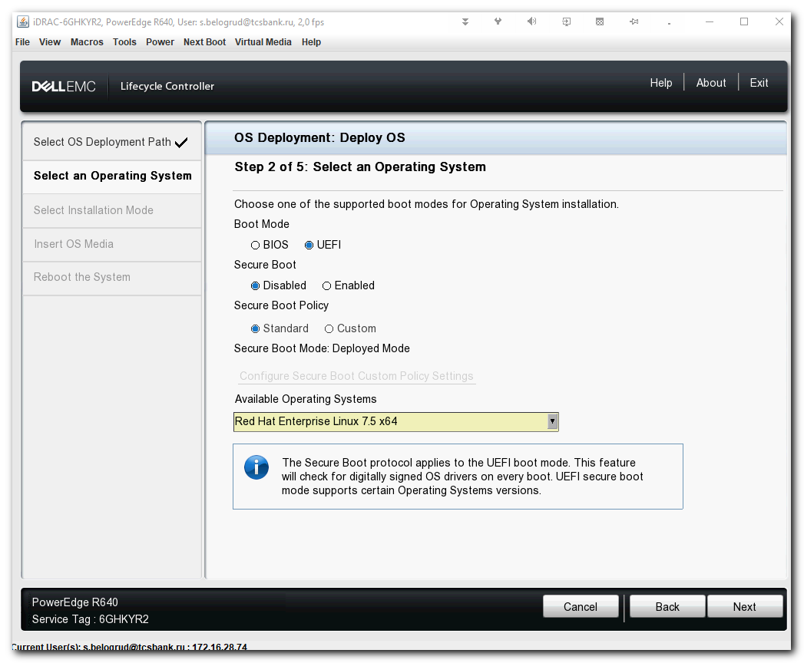
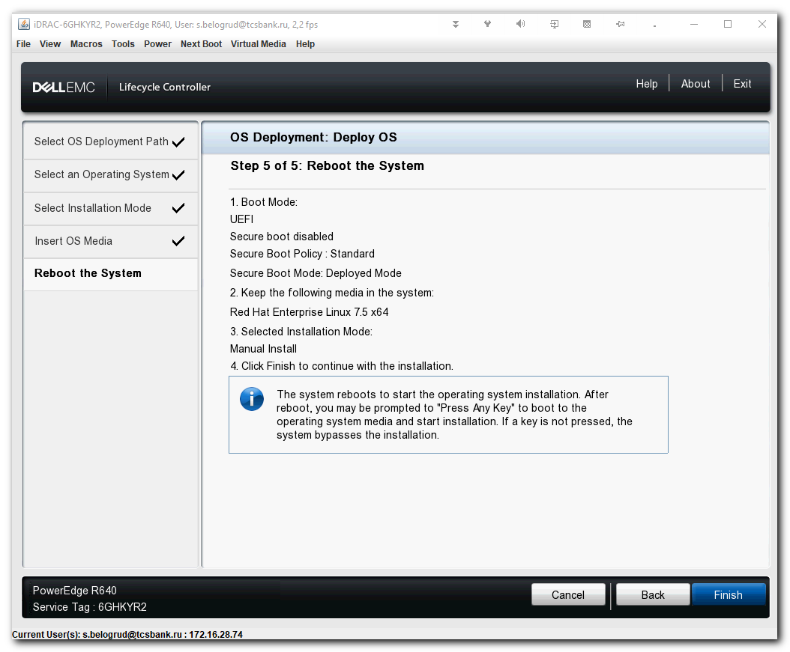

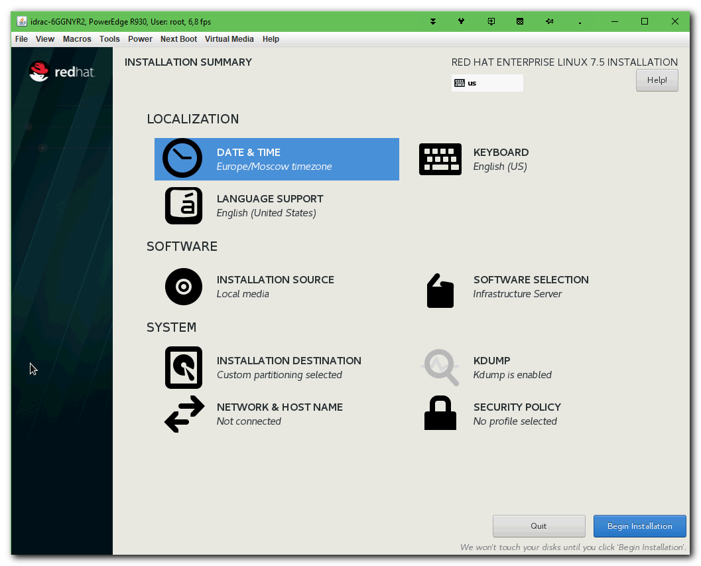
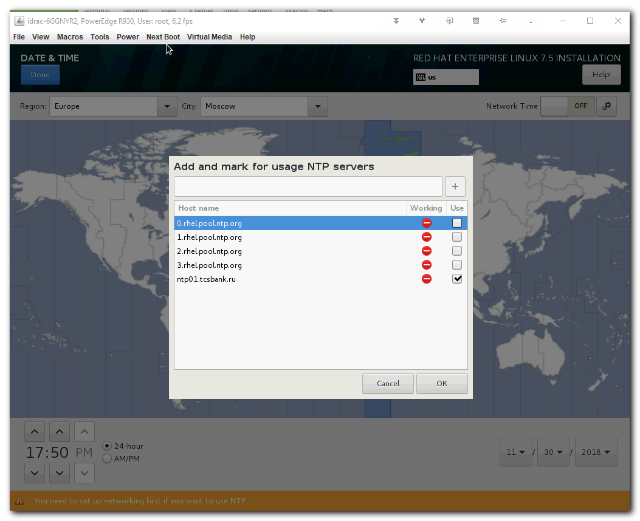

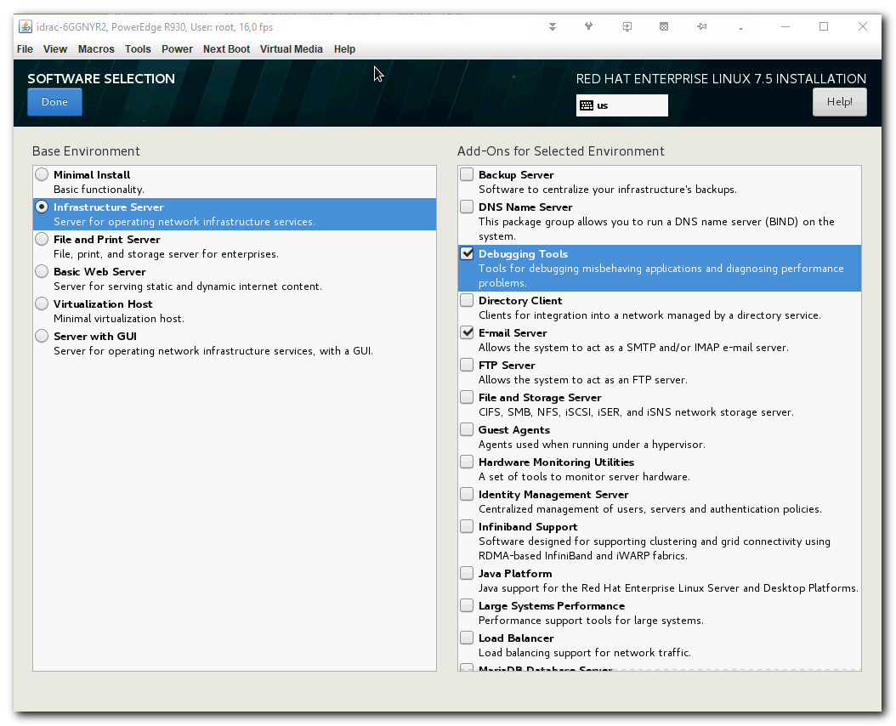
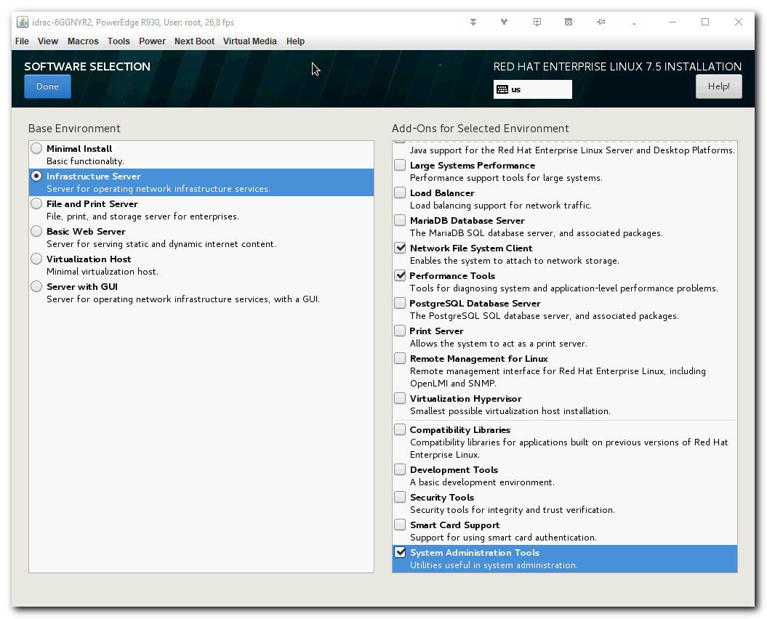
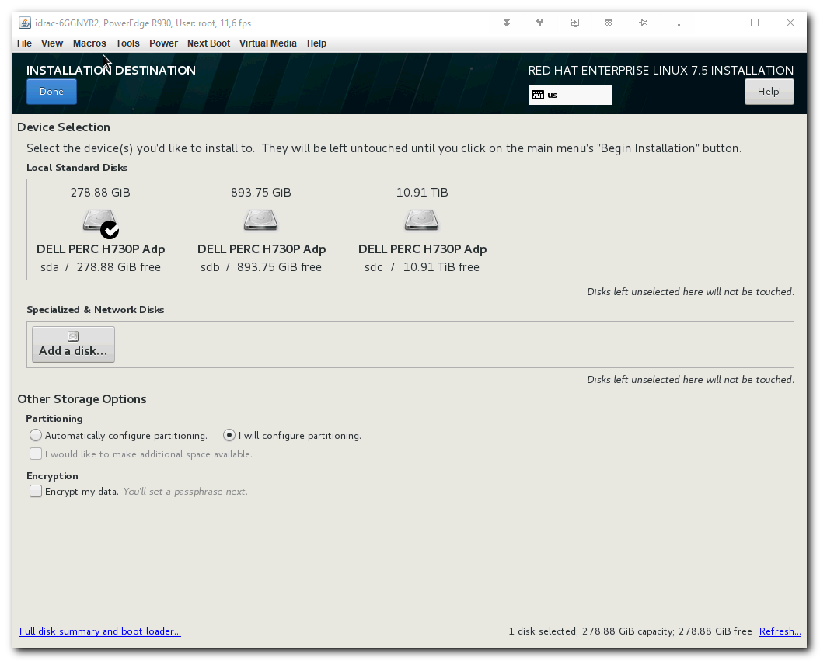

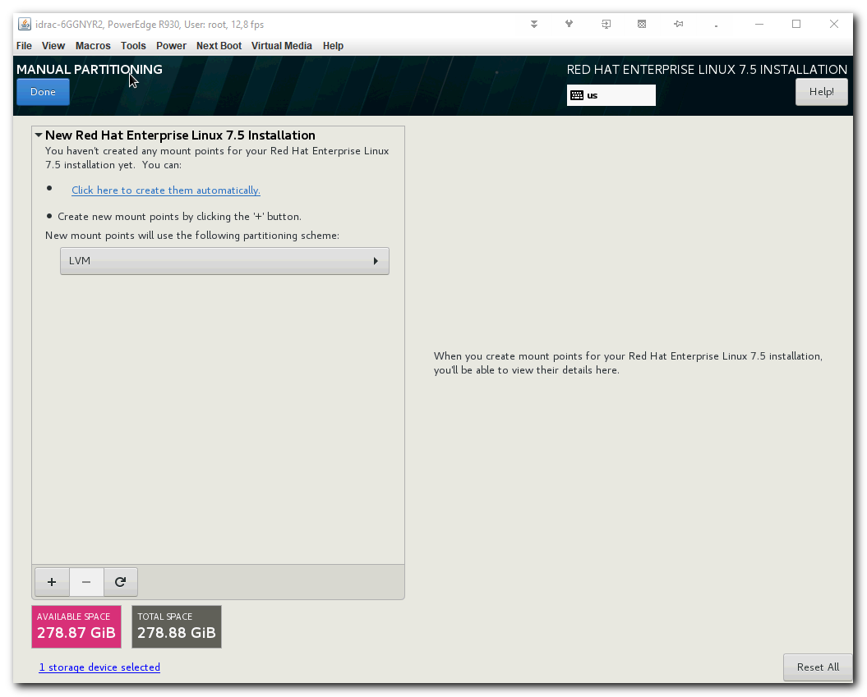
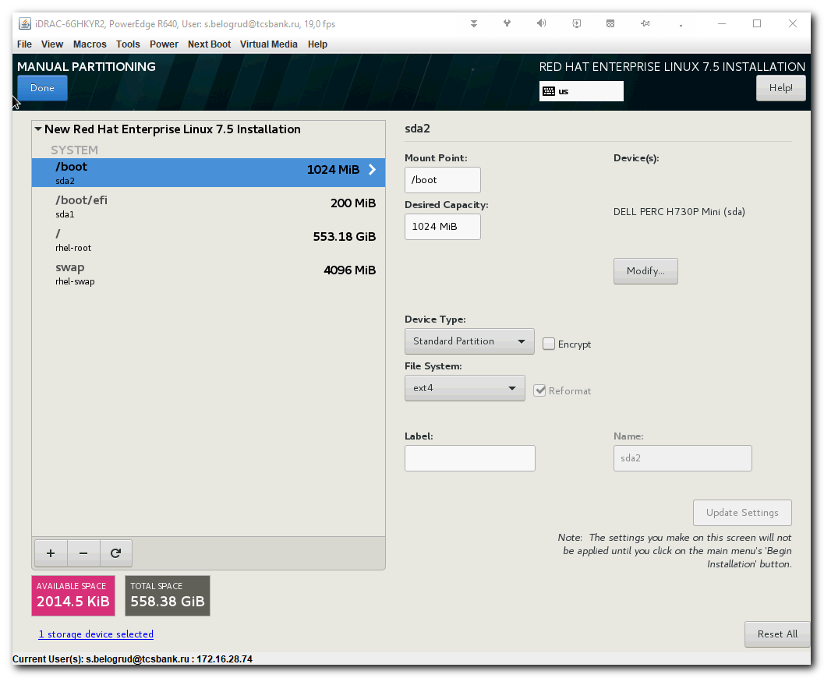

#
# On servers, during installation, I've configured one interface very simply.
# I've found free ip address.
#
[s.belogrud@TCS4357]# ssh bsv@vm-pxe01p
Last login: Thu Sep 27 16:42:12 2018 from 172.16.28.74
[bsv@vm-pxe01p ~]$ sudo -
[sudo] password for bsv:
[bsv@vm-pxe01p ~]$ sudo -i
[sudo] password for bsv:
[root@vm-pxe01p ~]# grep -ie "fixed-address" /etc/dhcp/dhcpd.conf
fixed-address 10.218.15.123;
fixed-address 10.218.15.126;
fixed-address 10.218.15.130;
fixed-address 10.218.15.112;
fixed-address 10.218.15.127;
fixed-address 10.218.15.131;
fixed-address 10.218.15.124;
fixed-address 10.218.15.133;
fixed-address 10.218.15.134;
fixed-address 192.168.1.100;
fixed-address 10.218.15.128;
fixed-address 10.218.15.120;
fixed-address 10.218.15.129;
fixed-address 10.218.15.125;
fixed-address 10.218.15.135;
fixed-address 10.218.15.111;
fixed-address 10.218.15.122;
fixed-address 10.218.15.121;
fixed-address 10.218.15.132;
fixed-address 10.218.15.2;
[root@vm-pxe01p ~]#
#
# As usually - disable ipv6, manually configure ip address 10.218.15.42 its netmask 24 and gateway 10.218.15.254 and dns names, I've taken it from vm-pxe01p. And I've written dns suffix tcsbank.ru. Everything very simple and as usually.
#

[root@ds-afs-prod02 ~]# cat /etc/sysconfig/network-scripts/ifcfg-em1
TYPE=Ethernet
PROXY_METHOD=none
BROWSER_ONLY=no
BOOTPROTO=none
DEFROUTE=yes
IPV4_FAILURE_FATAL=no
IPV6INIT=no
IPV6_AUTOCONF=yes
IPV6_DEFROUTE=yes
IPV6_FAILURE_FATAL=no
IPV6_ADDR_GEN_MODE=stable-privacy
NAME=em1
UUID=48f48b74-c7e0-4dc7-868e-ad4e4bbe8a6d
DEVICE=em1
ONBOOT=no
IPADDR=10.218.15.42
PREFIX=24
GATEWAY=10.218.15.254
DNS1=10.216.41.4
DNS2=10.216.42.4
DOMAIN=tcsbank.ru
[root@ds-afs-prod02 ~]#

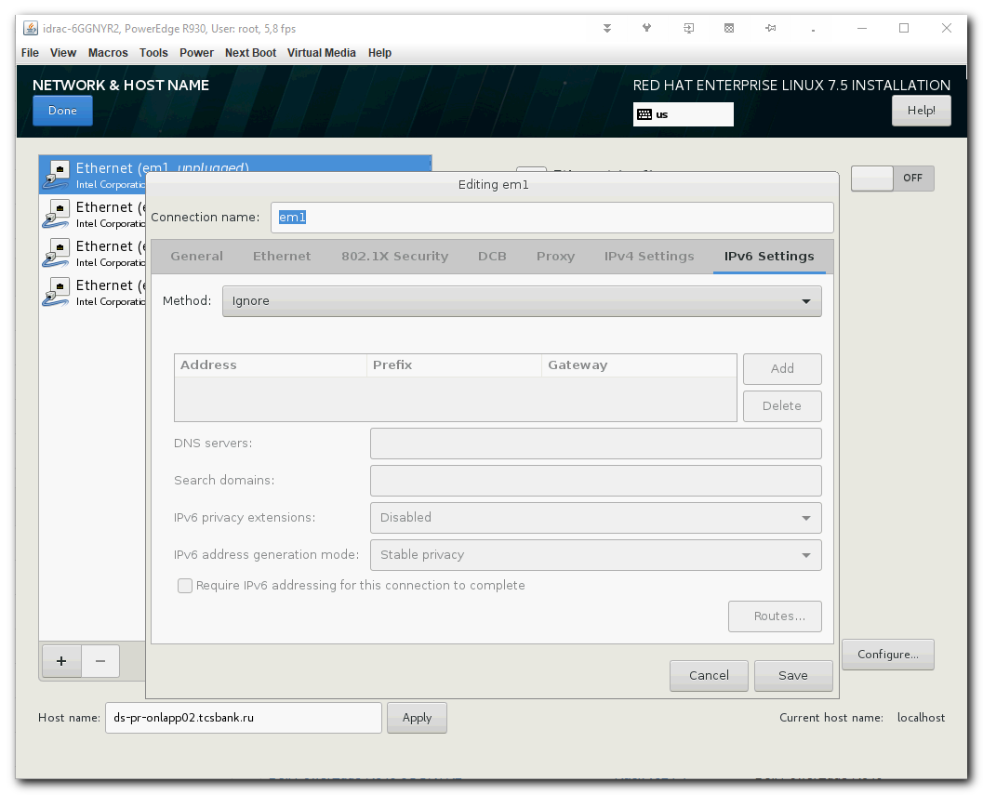
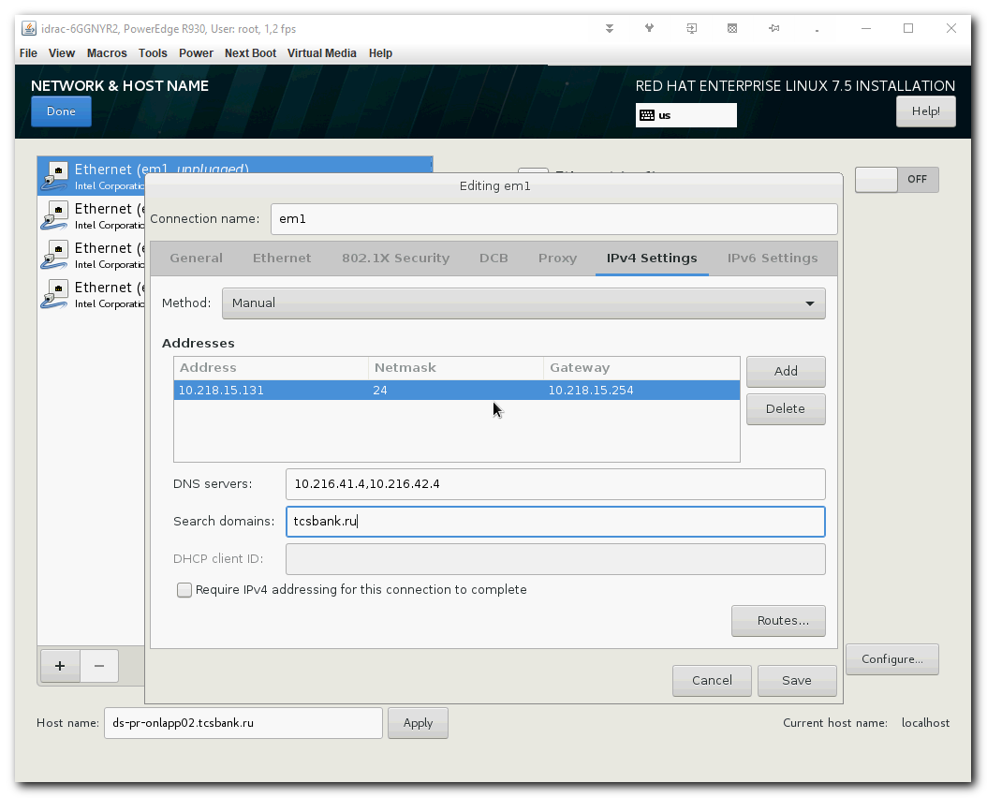
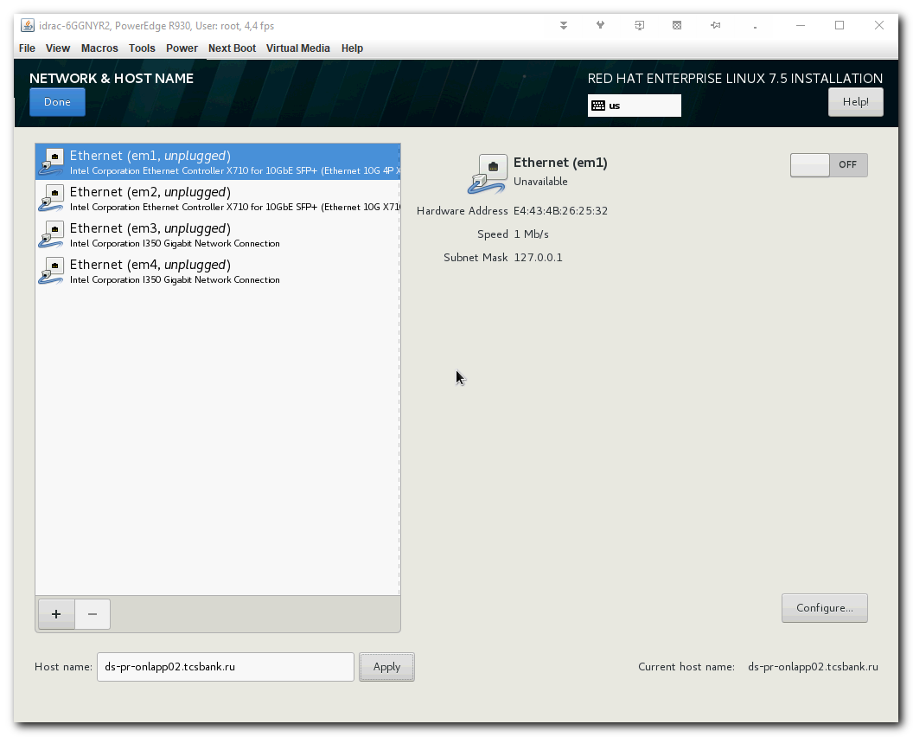

#
# After servers booted, on both servers was made default procedure.
# Was disabled selinux, stopped NetworkManager, stopped firewalld.
#
1 ip -f inet addr
2 ls -Alh /etc/sysconfig/network-scripts/ifcfg-*
3 vim /etc/selinux/config
4 systemctl stop NetworkManager
5 systemctl disable NetworkManager
6 systemctl stop firewalld
7 systemctl disable firewalld
8 reboot
9 ip -f inet addr

#
# Garnyshev Igor have configured VLAN 1815 on both of target servers.
# Port on commutator was configured as "access" - that's means it's without tagging.
#
# I've tested available gateway from console.
#
[root@ds-afs-prod02 ~]# ping -c 3 10.218.15.254
PING 10.218.15.254 (10.218.15.254) 56(84) bytes of data.
64 bytes from 10.218.15.254: icmp_seq=1 ttl=64 time=1.08 ms
64 bytes from 10.218.15.254: icmp_seq=2 ttl=64 time=1.14 ms
64 bytes from 10.218.15.254: icmp_seq=3 ttl=64 time=1.20 ms

--- 10.218.15.254 ping statistics ---
3 packets transmitted, 3 received, 0% packet loss, time 2004ms
rtt min/avg/max/mdev = 1.086/1.145/1.205/0.062 ms
[root@ds-afs-prod02 ~]#

#
# I've logged in on both servers.
#
[s.belogrud@TCS4357]# ssh root@10.218.15.42
Warning: Permanently added '10.218.15.42' (ECDSA) to the list of known hosts.
root@10.218.15.42's password:
Last login: Tue Dec 4 22:05:14 2018
[root@ds-afs-prod02 ~]#

[root@ds-afs-prod02 ~]# ip -f inet addr
1: lo: <LOOPBACK,UP,LOWER_UP> mtu 65536 qdisc noqueue state UNKNOWN group default qlen 1000
inet 127.0.0.1/8 scope host lo
valid_lft forever preferred_lft forever
2: em1: <BROADCAST,MULTICAST,UP,LOWER_UP> mtu 1500 qdisc mq state UP group default qlen 1000
inet 10.218.15.42/24 brd 10.218.15.255 scope global em1
valid_lft forever preferred_lft forever

[root@ds-afs-prod02 ~]# puppet agent -t
-bash: puppet: command not found
[root@ds-afs-prod02 ~]# logout
Connection to 10.218.15.42 closed.

#
# Then I've ran puppet installation via ansible.
#
[support@centos puppet]$ ansible-playbook 20180808-1512.install.puppet-agent.yaml -i 20180808-1512.list_of_hosts --become --extra-vars "ansible_user=root ansible_password=$(pass common/linux-default) ansible_ssh_common_args='-oStrictHostKeyChecking=no -oPubkeyAuthentication=no'"

PLAY [all] *******************************************************************************************************************************************************************************************

TASK [Gathering Facts] *******************************************************************************************************************************************************************************
ok: [10.218.15.42]
ok: [10.218.15.41]

TASK [Add Puppetlabs Repo v5 (rpm) for RHEL] *********************************************************************************************************************************************************
changed: [10.218.15.42]
changed: [10.218.15.41]

TASK [Add Puppetlabs Repo v5 (deb)] ******************************************************************************************************************************************************************
skipping: [10.218.15.42]
skipping: [10.218.15.41]

TASK [Add Puppetlabs Repo key (deb)] *****************************************************************************************************************************************************************
skipping: [10.218.15.42]
skipping: [10.218.15.41]

TASK [Install puppet-agent via apt module on Ubuntu with option -y] **********************************************************************************************************************************
skipping: [10.218.15.42]
skipping: [10.218.15.41]

TASK [Install new puppet] ****************************************************************************************************************************************************************************
changed: [10.218.15.41]
changed: [10.218.15.42]

TASK [Set puppet server in config] *******************************************************************************************************************************************************************
changed: [10.218.15.42]
changed: [10.218.15.41]

TASK [Enable agent (for ubuntu)] *********************************************************************************************************************************************************************
skipping: [10.218.15.42]
skipping: [10.218.15.41]

TASK [First run puppet] ******************************************************************************************************************************************************************************
fatal: [10.218.15.41]: FAILED! => {"changed": false, "disabled": false, "error": true, "msg": "puppet did not run", "rc": 1, "stderr": "", "stderr_lines": [], "stdout": "Info: Creating a new SSL key for m1-afs-prod02.tcsbank.ru\nInfo: Caching certificate for ca\nInfo: csr_attributes file loading from /etc/puppetlabs/puppet/csr_attributes.yaml\nInfo: Creating a new SSL certificate request for m1-afs-prod02.tcsbank.ru\nInfo: Certificate Request fingerprint (SHA256): 76:36:E5:97:C6:D4:00:B8:FE:80:43:9F:36:0D:76:8E:63:1F:88:FE:C3:B2:85:DB:33:DE:AA:07:CD:69:E3:BB\nInfo: Caching certificate for ca\nExiting; no certificate found and waitforcert is disabled\n", "stdout_lines": ["Info: Creating a new SSL key for m1-afs-prod02.tcsbank.ru", "Info: Caching certificate for ca", "Info: csr_attributes file loading from /etc/puppetlabs/puppet/csr_attributes.yaml", "Info: Creating a new SSL certificate request for m1-afs-prod02.tcsbank.ru", "Info: Certificate Request fingerprint (SHA256): 76:36:E5:97:C6:D4:00:B8:FE:80:43:9F:36:0D:76:8E:63:1F:88:FE:C3:B2:85:DB:33:DE:AA:07:CD:69:E3:BB", "Info: Caching certificate for ca", "Exiting; no certificate found and waitforcert is disabled"]}
...ignoring
fatal: [10.218.15.42]: FAILED! => {"changed": false, "disabled": false, "error": true, "msg": "puppet did not run", "rc": 1, "stderr": "", "stderr_lines": [], "stdout": "Info: Creating a new SSL key for ds-afs-prod02.tcsbank.ru\nInfo: Caching certificate for ca\nInfo: csr_attributes file loading from /etc/puppetlabs/puppet/csr_attributes.yaml\nInfo: Creating a new SSL certificate request for ds-afs-prod02.tcsbank.ru\nInfo: Certificate Request fingerprint (SHA256): 99:1F:65:D4:56:1F:2B:57:84:20:14:A5:33:5D:C7:F8:1F:07:62:28:D0:10:F3:B3:5A:AE:B8:80:97:0A:09:0E\nInfo: Caching certificate for ca\nExiting; no certificate found and waitforcert is disabled\n", "stdout_lines": ["Info: Creating a new SSL key for ds-afs-prod02.tcsbank.ru", "Info: Caching certificate for ca", "Info: csr_attributes file loading from /etc/puppetlabs/puppet/csr_attributes.yaml", "Info: Creating a new SSL certificate request for ds-afs-prod02.tcsbank.ru", "Info: Certificate Request fingerprint (SHA256): 99:1F:65:D4:56:1F:2B:57:84:20:14:A5:33:5D:C7:F8:1F:07:62:28:D0:10:F3:B3:5A:AE:B8:80:97:0A:09:0E", "Info: Caching certificate for ca", "Exiting; no certificate found and waitforcert is disabled"]}
...ignoring

PLAY RECAP *******************************************************************************************************************************************************************************************
10.218.15.41 : ok=5 changed=3 unreachable=0 failed=0
10.218.15.42 : ok=5 changed=3 unreachable=0 failed=0

[support@centos puppet]$

[s.belogrud@TCS4357]# ssh root@10.218.15.42
Last login: Wed Dec 5 13:35:41 2018 from tcs4357.tcsbank.ru
[root@ds-afs-prod02 ~]# puppet agent -t
Exiting; no certificate found and waitforcert is disabled
[root@ds-afs-prod02 ~]#

[root@vm-puppetmaster02p ~]# puppet cert list -a | egrep -e "afs-prod"
"ds-afs-prod02.tcsbank.ru" (SHA256) 99:1F:65:D4:56:1F:2B:57:84:20:14:A5:33:5D:C7:F8:1F:07:62:28:D0:10:F3:B3:5A:AE:B8:80:97:0A:09:0E
"m1-afs-prod02.tcsbank.ru" (SHA256) 76:36:E5:97:C6:D4:00:B8:FE:80:43:9F:36:0D:76:8E:63:1F:88:FE:C3:B2:85:DB:33:DE:AA:07:CD:69:E3:BB
+ "ds-afs-prod.tcsbank.ru" (SHA256) 40:48:C7:A9:AA:53:39:04:67:5A:5E:B4:0A:E3:E0:A0:82:AA:03:3E:64:B0:50:60:76:DF:64:E6:0D:0A:CA:4D
[root@vm-puppetmaster02p ~]#

[root@vm-puppetmaster02p ~]# puppet cert sign "m1-afs-prod02.tcsbank.ru"
Signing Certificate Request for:
"m1-afs-prod02.tcsbank.ru" (SHA256) 76:36:E5:97:C6:D4:00:B8:FE:80:43:9F:36:0D:76:8E:63:1F:88:FE:C3:B2:85:DB:33:DE:AA:07:CD:69:E3:BB
Notice: Signed certificate request for m1-afs-prod02.tcsbank.ru
Notice: Removing file Puppet::SSL::CertificateRequest m1-afs-prod02.tcsbank.ru at '/etc/puppetlabs/puppet/ssl/ca/requests/m1-afs-prod02.tcsbank.ru.pem'
[root@vm-puppetmaster02p ~]# puppet cert sign "ds-afs-prod02.tcsbank.ru"
Signing Certificate Request for:
"ds-afs-prod02.tcsbank.ru" (SHA256) 99:1F:65:D4:56:1F:2B:57:84:20:14:A5:33:5D:C7:F8:1F:07:62:28:D0:10:F3:B3:5A:AE:B8:80:97:0A:09:0E
Notice: Signed certificate request for ds-afs-prod02.tcsbank.ru
Notice: Removing file Puppet::SSL::CertificateRequest ds-afs-prod02.tcsbank.ru at '/etc/puppetlabs/puppet/ssl/ca/requests/ds-afs-prod02.tcsbank.ru.pem'
[root@vm-puppetmaster02p ~]#

#
# Let's run puppet to apply base config on servers.
#
[root@m1-afs-prod02 ~]# puppet agent -t
Info: Caching certificate for m1-afs-prod02.tcsbank.ru
Info: Caching certificate_revocation_list for ca
Info: Caching certificate for m1-afs-prod02.tcsbank.ru
Info: Using configured environment 'production'
Info: Retrieving pluginfacts
Info: Retrieving plugin
Notice: /File[/opt/puppetlabs/puppet/cache/lib/1.8.7]/ensure: created
Notice: /File[/opt/puppetlabs/puppet/cache/lib/1.8.7/csv.rb]/ensure: defined content as '{md5}1637aa570ea2ab7f6caf851de779f4d9'
Notice: /File[/opt/puppetlabs/puppet/cache/lib/easy_type]/ensure: created
...

................................................................................

#
# Next step was configured custom config in puppet to apply it on these two servers.
#
[s.belogrud@TCS4357]# git checkout -b 20181205_SD1357396
Switched to a new branch '20181205_SD1357396'

[s.belogrud@TCS4357]# git --no-pager log -n 1 -p manifests/00_site.pp
commit e4f8ee25fd8dd8da184b4926dc0684390f4bc5c9
Author: Sergey Belogrud <s.belogrud@tinkoff.ru>
Date: Wed Dec 5 12:20:16 2018 +0300

SD#1357396. Access to server for user.

diff --git a/manifests/00_site.pp b/manifests/00_site.pp
index 279d0da..5abeea2 100644
--- a/manifests/00_site.pp
+++ b/manifests/00_site.pp
@@ -132,6 +132,9 @@ node 'vm-sso-prod-zipkin-1.tcsbank.ru' {
node /^(ds|m1)-afs-prod\.tcsbank\.ru$/ {
include role::afs_prod
}
+node /^(ds|m1)-afs-prod\d+\.tcsbank\.ru$/ {
+ include role::afs_prod
+}
node /^(ds|m1)-pr-pg-encashment\d+\.tcsbank\.ru$/ {
include role::pr_encashment
}
[s.belogrud@TCS4357]#

[s.belogrud@TCS4357]# git status
On branch 20181205_SD1357396
Changes not staged for commit:
(use "git add <file>..." to update what will be committed)
(use "git checkout -- <file>..." to discard changes in working directory)

modified: manifests/00_site.pp

no changes added to commit (use "git add" and/or "git commit -a")
[s.belogrud@TCS4357]# git commit --author='Sergey Belogrud <s.belogrud@tinkoff.ru>' -m "SD#1357396. Access to server for user." manifests/00_site.pp
[20181205_SD1357396 e4f8ee2] SD#1357396. Access to server for user.
Author: Sergey Belogrud <s.belogrud@tinkoff.ru>
1 file changed, 3 insertions(+)
[s.belogrud@TCS4357]# git push origin 20181205_SD1357396
Counting objects: 4, done.
Delta compression using up to 8 threads.
Compressing objects: 100% (4/4), done.
Writing objects: 100% (4/4), 427 bytes | 0 bytes/s, done.
Total 4 (delta 3), reused 0 (delta 0)
remote:
remote: *** Checking puppet code style ***
remote:
remote: *** Checking puppet manifest syntax ***
remote:
remote: *** Checking puppet template(epp) syntax ***
remote:
remote: *** Checking ruby template(erb) syntax ***
remote:
remote: *** Checking ruby syntax ***
remote:
remote: *** Checking YAML syntax ***
remote:
remote: To create a merge request for 20181205_SD1357396, visit:
remote: https://vm-gitlab01.tcsbank.ru/Puppet/control/merge_requests/new?merge_request%5Bsource_branch%5D=20181205_SD1357396
remote:
To git@vm-gitlab01.tcsbank.ru:Puppet/control.git
* [new branch] 20181205_SD1357396 -> 20181205_SD1357396
[s.belogrud@TCS4357]#

[root@ds-afs-prod02 ~]# puppet agent -t
Info: Using configured environment 'production'
Info: Retrieving pluginfacts
Info: Retrieving plugin
Info: Loading facts
Info: Caching catalog for ds-afs-prod02.tcsbank.ru
Info: Applying configuration version 'vm-puppetmaster02p.tcsbank.ru-production-adb28fc9228'
Notice: /Stage[main]/Profile::Accounts::Dwhusers/Group[dwhusers]/ensure: created
Notice: /Stage[main]/Profile::Accounts::Afsadmin/Group[afsadmin]/ensure: created
Notice: /Stage[main]/Profile::Accounts::Afsadmin/User[afsadmin]/ensure: created
Notice: /Stage[main]/Profile::Accounts::Afsadmin/File[/etc/sudoers.d/afsadmin]/ensure: defined content as '{md5}df9a79017f58874e871d7581bc147fe8'
Notice: /Stage[main]/Profile::Accounts::Agolovin/Group[a.golovin]/ensure: created
Notice: /Stage[main]/Profile::Accounts::Agolovin/User[a.golovin]/ensure: created
Notice: /Stage[main]/Profile::Accounts::Inikitin/Group[i.nikitin]/ensure: created
Notice: /Stage[main]/Profile::Accounts::Inikitin/User[i.nikitin]/ensure: created
Notice: /Stage[main]/Profile::Accounts::Ylitvin/Group[y.litvin]/ensure: created
Notice: /Stage[main]/Profile::Accounts::Ylitvin/User[y.litvin]/ensure: created
Notice: /Stage[main]/Splunk::Forwarder/Package[install splunk forwarder]/ensure: created
Notice: /Stage[main]/Splunk::Forwarder/Exec[accept splunk forwarder license]/returns: executed successfully
Notice: /Stage[main]/Splunk::Forwarder/Exec[create splunk forwarder init file]/returns: executed successfully
Notice: /Stage[main]/Splunk::Forwarder/File[splunk forwarder deploymentclient configuration]/ensure: defined content as '{md5}304c39c416926482540712301c23d47b'
Info: /Stage[main]/Splunk::Forwarder/File[splunk forwarder deploymentclient configuration]: Scheduling refresh of Service[splunk]
Notice: /Stage[main]/Splunk::Forwarder/Service[splunk]/ensure: ensure changed 'stopped' to 'running'
Info: /Stage[main]/Splunk::Forwarder/Service[splunk]: Unscheduling refresh on Service[splunk]
Notice: Applied catalog in 3.70 seconds
[root@ds-afs-prod02 ~]#

................................................................................

[root@ds-afs-prod02 ~]# pvcreate /dev/sdb
Physical volume "/dev/sdb" successfully created.

[root@ds-afs-prod02 ~]# vgcreate data /dev/sdb
Volume group "data" successfully created

[root@ds-afs-prod02 ~]# lvcreate -l 100%VG data -n lv0
Logical volume "lv0" created.
[root@ds-afs-prod02 ~]#

[root@ds-afs-prod02 ~]# lvs
LV VG Attr LSize Pool Origin Data% Meta% Move Log Cpy%Sync Convert
lv0 data -wi-a----- <893.75g
root rhel -wi-ao---- <553.18g
swap rhel -wi-ao---- 4.00g
[root@ds-afs-prod02 ~]# mkfs.ext4 /dev/mapper/data-lv0
mke2fs 1.42.9 (28-Dec-2013)
Filesystem label=
OS type: Linux
Block size=4096 (log=2)
Fragment size=4096 (log=2)
Stride=0 blocks, Stripe width=0 blocks
58572800 inodes, 234290176 blocks
11714508 blocks (5.00%) reserved for the super user
First data block=0
Maximum filesystem blocks=2382364672
7150 block groups
32768 blocks per group, 32768 fragments per group
8192 inodes per group
Superblock backups stored on blocks:
32768, 98304, 163840, 229376, 294912, 819200, 884736, 1605632, 2654208,
4096000, 7962624, 11239424, 20480000, 23887872, 71663616, 78675968,
102400000, 214990848

Allocating group tables: done
Writing inode tables: done
Creating journal (32768 blocks): done
Writing superblocks and filesystem accounting information: done

[root@ds-afs-prod02 ~]#

[root@ds-afs-prod02 ~]# mkdir /mnt/afs
[root@ds-afs-prod02 ~]# vim /etc/fstab
[root@ds-afs-prod02 ~]# mount /mnt/afs
[root@ds-afs-prod02 ~]# cat /etc/fstab

#
# /etc/fstab
# Created by anaconda on Tue Dec 4 21:47:10 2018
#
# Accessible filesystems, by reference, are maintained under '/dev/disk'
# See man pages fstab(5), findfs(8), mount(8) and/or blkid(8) for more info
#
/dev/mapper/rhel-root / ext4 defaults 1 1
UUID=e94afcf3-8afa-4543-ad72-eef3e145d3bd /boot ext4 defaults 1 2
UUID=BAB4-59FE /boot/efi vfat umask=0077,shortname=winnt 0 0
/dev/mapper/rhel-swap swap swap defaults 0 0
/dev/mapper/data-lv0 /mnt/afs ext4 defaults 0 0
[root@ds-afs-prod02 ~]#

[root@ds-afs-prod02 ~]# lsblk
NAME MAJ:MIN RM SIZE RO TYPE MOUNTPOINT
sda 8:0 0 558.4G 0 disk
├─sda1 8:1 0 200M 0 part /boot/efi
├─sda2 8:2 0 1G 0 part /boot
└─sda3 8:3 0 557.2G 0 part
├─rhel-root 253:0 0 553.2G 0 lvm /
└─rhel-swap 253:1 0 4G 0 lvm [SWAP]
sdb 8:16 0 893.8G 0 disk
└─data-lv0 253:2 0 893.8G 0 lvm /mnt/afs
sr0 11:0 1 1024M 0 rom
[root@ds-afs-prod02 ~]#

................................................................................

[root@ds-afs-prod02 network-scripts]# for var1 in $(ls -A1 /etc/sysconfig/network-scripts/ifcfg-*) ; do echo ;echo ${var1} ; cat ${var1} ; done

/etc/sysconfig/network-scripts/ifcfg-em1
TYPE=Ethernet
PROXY_METHOD=none
BROWSER_ONLY=no
BOOTPROTO=none
DEFROUTE=no
IPV4_FAILURE_FATAL=no
IPV6INIT=no
IPV6_AUTOCONF=yes
IPV6_DEFROUTE=yes
IPV6_FAILURE_FATAL=no
IPV6_ADDR_GEN_MODE=stable-privacy
NAME=em1
UUID=48f48b74-c7e0-4dc7-868e-ad4e4bbe8a6d
DEVICE=em1
ONBOOT=yes
DEVICETYPE=TeamPort
TEAM_MASTER=team0
TEAM_PORT_CONFIG='{"prio":100}'
MTU=9000
NM_CONTROLLED=no

/etc/sysconfig/network-scripts/ifcfg-em2
TYPE=Ethernet
PROXY_METHOD=none
BROWSER_ONLY=no
BOOTPROTO=none
DEFROUTE=no
IPV4_FAILURE_FATAL=no
IPV6INIT=no
IPV6_AUTOCONF=yes
IPV6_DEFROUTE=yes
IPV6_FAILURE_FATAL=no
IPV6_ADDR_GEN_MODE=stable-privacy
NAME=em2
UUID=57d56491-7a57-4a88-91f3-cca615aa62c5
DEVICE=em2
ONBOOT=yes
DEVICETYPE=TeamPort
TEAM_MASTER=team0
TEAM_PORT_CONFIG='{"prio":100}'
MTU=9000
NM_CONTROLLED=no

/etc/sysconfig/network-scripts/ifcfg-lo
DEVICE=lo
IPADDR=127.0.0.1
NETMASK=255.0.0.0
NETWORK=127.0.0.0
# If you're having problems with gated making 127.0.0.0/8 a martian,
# you can change this to something else (255.255.255.255, for example)
BROADCAST=127.255.255.255
ONBOOT=yes
NAME=loopback

/etc/sysconfig/network-scripts/ifcfg-team0
DEVICE=team0
PROXY_METHOD=none
BROWSER_ONLY=no
BOOTPROTO=none
DEFROUTE=no
IPV4_FAILURE_FATAL=no
IPV6INIT=no
IPV6_AUTOCONF=yes
IPV6_DEFROUTE=yes
IPV6_FAILURE_FATAL=no
IPV6_ADDR_GEN_MODE=stable-privacy
NAME=team0
ONBOOT=yes
DEVICETYPE=Team
# TEAM_CONFIG='{"runner":{"name":"activebackup"},"link_watch":{"name":"ethtool"}}'
TEAM_CONFIG='{"runner":{"name": "lacp","active": true,"fast_rate":true,"tx_hash": ["eth", "ipv4", "ipv6"]},"link_watch": {"name": "ethtool"}}'
MTU=9000
NM_CONTROLLED=no

/etc/sysconfig/network-scripts/ifcfg-team0.1632
DEVICE=team0.1632
TYPE=Ethernet
BOOTPROTO=none
DEFROUTE=yes
ONBOOT=yes
USERCTL=no
IPV6INIT=no
VLAN=yes
IPADDR=10.216.32.202
NETMASK=255.255.255.0
GATEWAY=10.216.32.254
MTU=1500
NM_CONTROLLED=no
[root@ds-afs-prod02 network-scripts]#

[root@ds-afs-prod02 ~]# teamdctl team0 state view
setup:
runner: lacp
ports:
em1
link watches:
link summary: up
instance[link_watch_0]:
name: ethtool
link: up
down count: 0
runner:
aggregator ID: 2, Selected
selected: yes
state: current
em2
link watches:
link summary: up
instance[link_watch_0]:
name: ethtool
link: up
down count: 0
runner:
aggregator ID: 2, Selected
selected: yes
state: current
runner:
active: yes
fast rate: yes
[root@ds-afs-prod02 ~]#

[root@ds-afs-prod02 ~]# teamdctl team0 state view -v
setup:
runner: lacp
kernel team mode: loadbalance
D-BUS enabled: yes
ZeroMQ enabled: no
debug level: 0
daemonized: no
PID: 45546
PID file: /var/run/teamd/team0.pid
ports:
em1
ifindex: 2
addr: f4:e9:d4:3f:6d:d4
ethtool link: 25000mbit/fullduplex/up
link watches:
link summary: up
instance[link_watch_0]:
name: ethtool
link: up
down count: 0
link up delay: 0
link down delay: 0
runner:
aggregator ID: 2, Selected
selected: yes
state: current
key: 0
priority: 255
actor LACPDU info:
system priority: 65535
system: f4:e9:d4:3f:6d:d4
key: 0
port_priority: 255
port: 2
state: 0x3f
partner LACPDU info:
system priority: 127
system: 01:25:26:08:08:11
key: 8
port_priority: 127
port: 8
state: 0x3f
em2
ifindex: 3
addr: f4:e9:d4:3f:6d:d4
ethtool link: 25000mbit/fullduplex/up
link watches:
link summary: up
instance[link_watch_0]:
name: ethtool
link: up
down count: 0
link up delay: 0
link down delay: 0
runner:
aggregator ID: 2, Selected
selected: yes
state: current
key: 0
priority: 255
actor LACPDU info:
system priority: 65535
system: f4:e9:d4:3f:6d:d4
key: 0
port_priority: 255
port: 3
state: 0x3f
partner LACPDU info:
system priority: 127
system: 01:25:26:08:08:11
key: 8
port_priority: 127
port: 8
state: 0x3f
runner:
active: yes
fast rate: yes
system priority: 65535
[root@ds-afs-prod02 ~]#

[root@ds-afs-prod02 ~]# ethtool -i em1
driver: qede
version: 8.10.10.21
firmware-version: mfw 8.24.44.0 storm 8.20.0.0
expansion-rom-version:
bus-info: 0000:19:00.0
supports-statistics: yes
supports-test: yes
supports-eeprom-access: no
supports-register-dump: yes
supports-priv-flags: yes
[root@ds-afs-prod02 ~]# lspci -s 0000:19:00.0
19:00.0 Ethernet controller: QLogic Corp. FastLinQ QL41000 Series 10/25/40/50GbE Controller (rev 02)
[root@ds-afs-prod02 ~]# lspci -s 0000:19:00.0 -v
19:00.0 Ethernet controller: QLogic Corp. FastLinQ QL41000 Series 10/25/40/50GbE Controller (rev 02)
Subsystem: QLogic Corp. Device 000c
Flags: bus master, fast devsel, latency 0, IRQ 123, NUMA node 0
Memory at 9e820000 (64-bit, prefetchable) [size=128K]
Memory at 9e000000 (64-bit, prefetchable) [size=8M]
Memory at 9e850000 (64-bit, prefetchable) [size=64K]
Expansion ROM at 9ec00000 [disabled] [size=512K]
Capabilities: [40] Power Management version 3
Capabilities: [50] MSI: Enable- Count=1/8 Maskable+ 64bit+
Capabilities: [70] Express Endpoint, MSI 00
Capabilities: [b0] MSI-X: Enable+ Count=129 Masked-
Capabilities: [d0] Vital Product Data
Capabilities: [100] Advanced Error Reporting
Capabilities: [148] Virtual Channel
Capabilities: [168] Device Serial Number 00-00-00-00-00-00-00-00
Capabilities: [178] Power Budgeting <?>
Capabilities: [188] Alternative Routing-ID Interpretation (ARI)
Capabilities: [198] #19
Capabilities: [1f8] Transaction Processing Hints
Capabilities: [284] Latency Tolerance Reporting
Capabilities: [28c] Vendor Specific Information: ID=0002 Rev=3 Len=100 <?>
Capabilities: [38c] Vendor Specific Information: ID=0001 Rev=1 Len=038 <?>
Capabilities: [3c4] Precision Time Measurement
Capabilities: [3d0] Vendor Specific Information: ID=0003 Rev=1 Len=054 <?>
Capabilities: [424] #15
Kernel driver in use: qede
Kernel modules: qede

[root@ds-afs-prod02 ~]#

................................................................................

[support@centos puppet]$ ansible-playbook 20180808-1512.install.puppet-agent.yaml -i 20180808-1512.list_of_hosts --become --extra-vars "ansible_user=root ansible_password=$(pass common/linux-default) ansible_ssh_common_args='-oStrictHostKeyChecking=no -oPubkeyAuthentication=no'"

PLAY [all] *******************************************************************************************************************************************************************************************

TASK [Gathering Facts] *******************************************************************************************************************************************************************************
ok: [10.216.32.201]
ok: [10.216.32.202]

TASK [Add Puppetlabs Repo v5 (rpm) for RHEL] *********************************************************************************************************************************************************
ok: [10.216.32.202]
ok: [10.216.32.201]

TASK [Add Puppetlabs Repo v5 (deb)] ******************************************************************************************************************************************************************
skipping: [10.216.32.202]
skipping: [10.216.32.201]

TASK [Add Puppetlabs Repo key (deb)] *****************************************************************************************************************************************************************
skipping: [10.216.32.202]
skipping: [10.216.32.201]

TASK [Install puppet-agent via apt module on Ubuntu with option -y] **********************************************************************************************************************************
skipping: [10.216.32.202]
skipping: [10.216.32.201]

TASK [Install new puppet] ****************************************************************************************************************************************************************************
ok: [10.216.32.202]
ok: [10.216.32.201]

TASK [Set puppet server in config] *******************************************************************************************************************************************************************
changed: [10.216.32.202]
changed: [10.216.32.201]

TASK [Enable agent (for ubuntu)] *********************************************************************************************************************************************************************
skipping: [10.216.32.202]
skipping: [10.216.32.201]

TASK [First run puppet] ******************************************************************************************************************************************************************************
ok: [10.216.32.201]
ok: [10.216.32.202]

PLAY RECAP *******************************************************************************************************************************************************************************************
10.216.32.201 : ok=5 changed=1 unreachable=0 failed=0
10.216.32.202 : ok=5 changed=1 unreachable=0 failed=0

[support@centos puppet]$

#
# The puppet is working well.
#
[root@m1-afs-prod02 ~]# puppet agent -t
Info: Using configured environment 'production'
Info: Retrieving pluginfacts
Info: Retrieving plugin
Info: Loading facts
Info: Caching catalog for m1-afs-prod02.tcsbank.ru
Info: Applying configuration version 'vm-puppetmaster02p.tcsbank.ru-production-b28f8dccf74'
Notice: Applied catalog in 1.43 seconds
[root@m1-afs-prod02 ~]#

................................................................................

#
# 20181211
#
[s.belogrud@TCS4357]# ssh bsv@m1-afs-prod02
Last login: Thu Dec 6 15:04:21 2018 from tcs4357.tcsbank.ru
'abrt-cli status' timed out
[bsv@m1-afs-prod02 ~]$ sudo -i
[sudo] password for bsv:
'abrt-cli status' timed out
[root@m1-afs-prod02 ~]#

[s.belogrud@TCS4357]# ssh bsv@ds-afs-prod02
Warning: Permanently added 'ds-afs-prod02' (ECDSA) to the list of known hosts.
Last login: Thu Dec 6 15:04:21 2018 from tcs4357.tcsbank.ru
[bsv@ds-afs-prod02 ~]$ sudo -i
[sudo] password for bsv:
[root@ds-afs-prod02 ~]#

#
# There were found follow articles:
# https://forums.cpanel.net/threads/strange-error-when-logging-in-as-root-via-ssh.590691/
# https://access.redhat.com/solutions/3077311
# https://bugzilla.redhat.com/show_bug.cgi?id=1249101
#

# Update - was not helped.
[root@m1-afs-prod02 ~]# yum install abrt

#
# What helped.
# As I see - something related with soft abrt doesn't work on this server correct.
#
[root@m1-afs-prod02 ~]# systemctl disable abrt-ccpp ; systemctl disable abrt-oops
Removed symlink /etc/systemd/system/multi-user.target.wants/abrt-ccpp.service.
Removed symlink /etc/systemd/system/multi-user.target.wants/abrt-oops.service.
[root@m1-afs-prod02 ~]# systemctl disable abrtd
Removed symlink /etc/systemd/system/multi-user.target.wants/abrtd.service.
[root@m1-afs-prod02 ~]#

[root@m1-afs-prod02 ~]# ps aux | grep -ie "abr[t]"
root 51245 99.7 64.8 1027879732 1027756992 ? R Dec05 8128:38 /usr/libexec/abrt-hook-ccpp 11 0 46174 0 0 1544030178 e 46174 46174 m1-afs-prod02.tcsbank.ru
root 65637 0.0 0.0 345912 6692 ? Sl Dec06 0:31 /usr/sbin/abrt-dbus -t133
[root@m1-afs-prod02 ~]# kill -9 65637
[root@m1-afs-prod02 ~]# kill -9 51245
[root@m1-afs-prod02 ~]# ps aux | grep -ie "abr[t]"
root 51245 99.7 0.0 0 0 ? R Dec05 8128:57 [abrt-hook-ccpp]
[root@m1-afs-prod02 ~]# kill -9 51245
[root@m1-afs-prod02 ~]# ps aux | grep -ie "abr[t]"
root 51245 99.7 0.0 0 0 ? R Dec05 8129:13 [abrt-hook-ccpp]
[root@m1-afs-prod02 ~]# logout
[bsv@m1-afs-prod02 ~]$ logout
Connection to m1-afs-prod02 closed.
[s.belogrud@TCS4357]# ssh bsv@m1-afs-prod02
Last login: Tue Dec 11 12:03:03 2018 from tcs4357.tcsbank.ru
[bsv@m1-afs-prod02 ~]$ sudo -i
[sudo] password for bsv:
[root@m1-afs-prod02 ~]#

[root@m1-afs-prod02 ~]# systemctl list-units --type service | grep -ie "abrt"
● abrtd.service loaded failed failed ABRT Automated Bug Reporting Tool
[root@m1-afs-prod02 ~]#

#
# Here is not problems.
# And how it looks.
#
[root@ds-afs-prod02 ~]# ps aux | grep -ie "abr[t]"
root 1653 0.0 0.0 223672 5692 ? Ss Dec04 0:00 /usr/sbin/abrtd -d -s
root 1661 0.0 0.0 221164 4724 ? Ss Dec04 0:02 /usr/bin/abrt-watch-log -F BUG: WARNING: at WARNING: CPU: INFO: possible recursive locking detected ernel BUG at list_del corruption list_add corruption do_IRQ: stack overflow: ear stack overflow (cur: eneral protection fault nable to handle kernel ouble fault: RTNL: assertion failed eek! page_mapcount(page) went negative! adness at NETDEV WATCHDOG ysctl table check failed : nobody cared IRQ handler type mismatch Kernel panic - not syncing: Machine Check Exception: Machine check events logged divide error: bounds: coprocessor segment overrun: invalid TSS: segment not present: invalid opcode: alignment check: stack segment: fpu exception: simd exception: iret exception: /var/log/messages -- /usr/bin/abrt-dump-oops -xtD
[root@ds-afs-prod02 ~]#

[root@ds-afs-prod02 ~]# systemctl stop abrtd ; systemctl disable abrtd ; systemctl stop abrt-ccpp ; systemctl disable abrt-ccpp ; systemctl stop abrt-oops ; systemctl disable abrt-oops
Removed symlink /etc/systemd/system/multi-user.target.wants/abrtd.service.
Removed symlink /etc/systemd/system/multi-user.target.wants/abrt-ccpp.service.
Removed symlink /etc/systemd/system/multi-user.target.wants/abrt-oops.service.
[root@ds-afs-prod02 ~]# ps aux | grep -ie "abr[t]"
[root@ds-afs-prod02 ~]#

[root@ds-afs-prod02 ~]# systemctl list-units --type service | grep -ie "abrt"
[root@ds-afs-prod02 ~]#

................................................................................

#
# Just to see what's differ between new and old servers.
#
[root@m1-afs-prod02 ~]# lsblk -o NAME,MOUNTPOINT,FSTYPE,SIZE
NAME MOUNTPOINT FSTYPE SIZE
sda 558.4G
├─sda1 /boot/efi vfat 200M
├─sda2 /boot ext4 1G
└─sda3 LVM2_member 557.2G
├─rhel-root / ext4 553.2G
└─rhel-swap [SWAP] swap 4G
sdb LVM2_member 893.8G
└─data-lv0 /mnt/afs ext4 893.8G
[root@m1-afs-prod02 ~]#

[root@m1-afs-prod ~]# lsblk -o NAME,MOUNTPOINT,FSTYPE,SIZE
NAME MOUNTPOINT FSTYPE SIZE
sr0 1024M
sdb LVM2_member 372.6G
└─vg_data-lvol0 (dm-1) /mnt/afs ext4 372.6G
sda 136.7G
├─sda1 /boot ext4 256M
├─sda2 [SWAP] swap 16G
├─sda3 LVM2_member 19.5G
│ ├─vg-LogVol00 (dm-0) / ext4 8G
│ └─vg-LogVol01 (dm-3) /var ext4 11.5G
├─sda4 1K
└─sda5 LVM2_member 100.9G
└─vg_opt-LogVol00 (dm-2) /opt ext4 100.9G
[root@m1-afs-prod ~]#

................................................................................

